**Gaia-X WG Hubs**

**Report Paris Workshop**

**Date / time: 8th April 2022 / 16:00 to 17:30 CET**

**Location:** CIGREF, Paris

Part 1 : Hub elevator pitches

Below you can see an overview of the priority domains mentioned in each hub’s elevator pitch. These were sorted based on the amount, and clearly the main priority domains can be identified as Health, Manufacturing & Industry and Mobility.



Part 2 : Clarity Exercise – Hubs & AISBL

A workshop was organized to try and capture the different challenges, open questions and outstanding issues between the Gaia-X hubs and the association. The full documentation you can find in the annex to this meeting. The main conclusions for this have been summarized.

As a first step, the different hubs rated some questions.

1. How well is your hub setup to create value for the ecosystem
2. How good is you onboarding in the ecosystem
3. How good is the cooperation between hubs and the associantion
4. How good is cooperation between other hubs

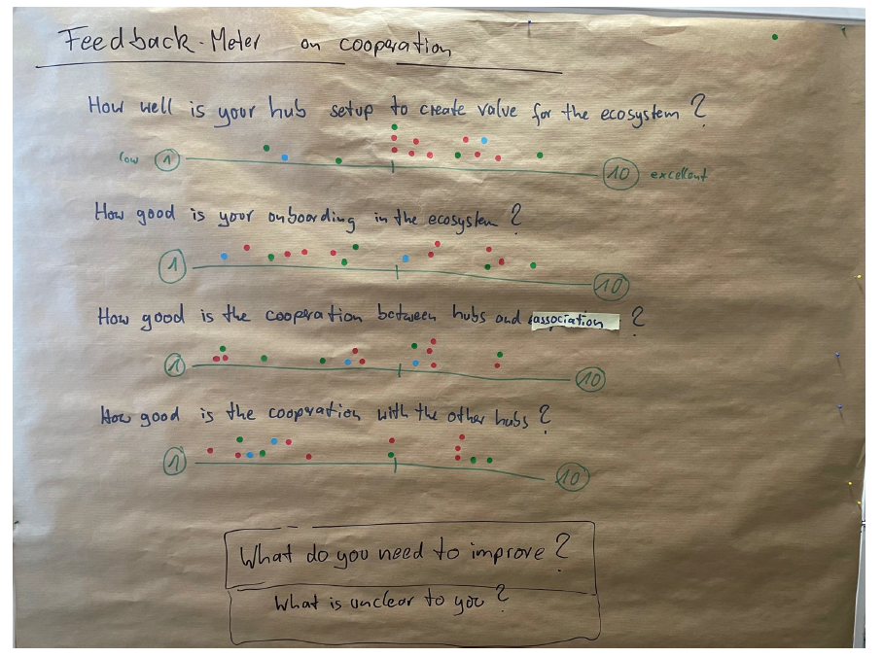

The results from this are very mixed, which leads us to the conclusion that between hubs there is a lot of difference in maturity.

During the group workshop the work was structured around identifying the challenges on processes, procedures, communication & structures. The outputs for this can be found in the images attached to this report. The main input was categorized into this:

* A lot of questions on **Value Propositions for Gaia-X adoption, Hub participation and AISBL membership**
* **Best practices and exchange of material** for communication activities: events, workshops, slide-decks, marketing fliers, pitches
* **How-to for all things Hub**: onboarding, marketing, operations, interfaces to AISBL, cooperation with other Hubs
* **Existing focus activities** (i.e. data spaces/verticals)
* Available **funding** (EU/national)

Part 3 : Interaction between hubs

As a final part, the hub coordinators were asked what according to them were the priority next steps. The list below is a rough overview, which still needs to be checked against the actions items.

**Interaction between Hubs - Workshop Next Steps :**

* Exchange of communication material
  + Increasing efficacy
* Setup of an easy communication channel (e.g. Slack)
* Setup of networking / matchmaking / cross country
* Organize more milestone events (eg. Health)
* Make communities/parts transparent
* Facilitate interaction between hubs
* Finding the similarities of the hub focus and connect hubs with similar focus
* Tooling
  + List that is editable in NextCloud
* Best practices of onboarding
* Sharing sessions fur hubs
* Best practices examples
* Matchmaking
  + On priorities
  + On projects
  + Platform
* Tenders
  + Bringing local ecosystem to EU tenders
* Value proposition
* Project exchange
  + Seeking/offering
* Alignment of project handling
* Agreeing on terminology
* Exchange session
* Map projects
* Clear communication

Action items

From all above discussions, some clear actions points are identified.

* **Complete Project List** (all Hubs)

If we want to work on Gaia-X projects and lighthouses, we should start with a longlist of usecases & projects.

An online sheet will be set-up to gather the input.

Hub coordinators are expected to engage with their local ecosystem and request input on usecases.

* Set up workshops on **value propositions** (lead AISBL, support WG Hubs)

A clear Gaia-X value proposition needs to be developed to help the hubs in engaging with their local ecosystem.

The main responsibility for this lies with the Gaia-X Aisbl.

Together with the WG Hubs this has to be delivered

* Operationalise **priority Data Spaces** (lead WG Hubs, support DSBC)
* Harmonise **communication efforts** (lead AISBL, support WG Hubs)